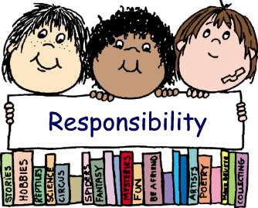

[This Photo](https://toughcookiemommy.com/2011/02/burdened-children.html) by Unknown Author is licensed under [CC BY-NC-ND](https://creativecommons.org/licenses/by-nc-nd/3.0/)

**BridgePrep Tampa POSTER COMPETITION**

What does a responsible student look like?

DUE: October 15, 2020

POSTER OR POWERPOINT ACCEPTED

MUST INCLUDE: Name, Grade, and HR Teacher

Please use color, graphics and label!

SUBMIT to Mrs. R. (media center) or email: arechnitzer@bridgepreptampa.com

1st, 2nd, and 3rd place prizes will be awarded!

 



[This Photo](http://trihiasmakeupsite.blogspot.com/2013_07_01_archive.html) by Unknown Author is licensed under [CC BY-ND](https://creativecommons.org/licenses/by-nd/3.0/)